**Git Task  
=========**

**1)** Create a repo in github with README.md and .ignore file.

README.md and .ignore file  
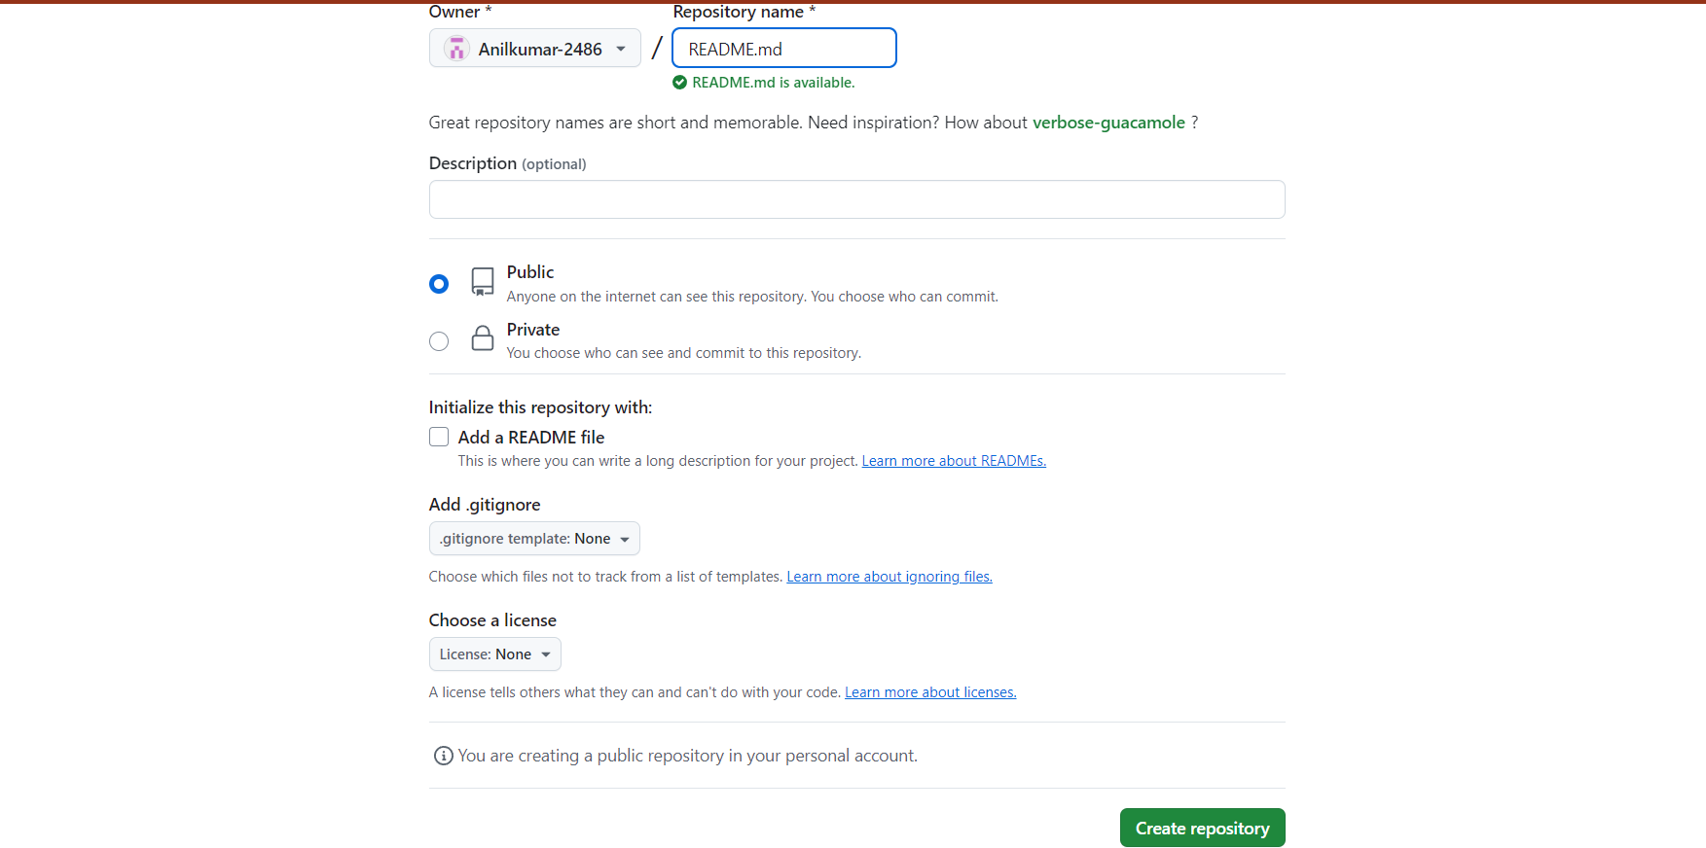

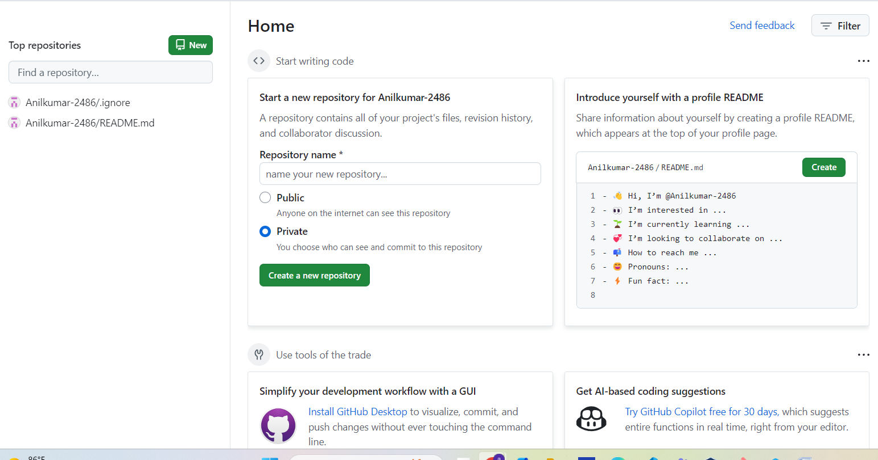

**2)** Clone the created repo to local

* Go to the repository on GitHub.
* Click the green "Code" button.
* Copy the URL we can choose HTTPS or SSH, depending on your setup.

*Navigate to the Directory Where You Want to Clone:  
* use this command git clone ( URL )

**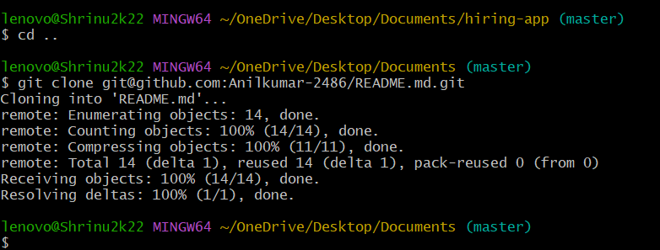  
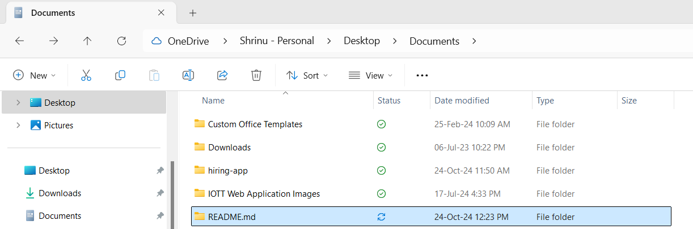  
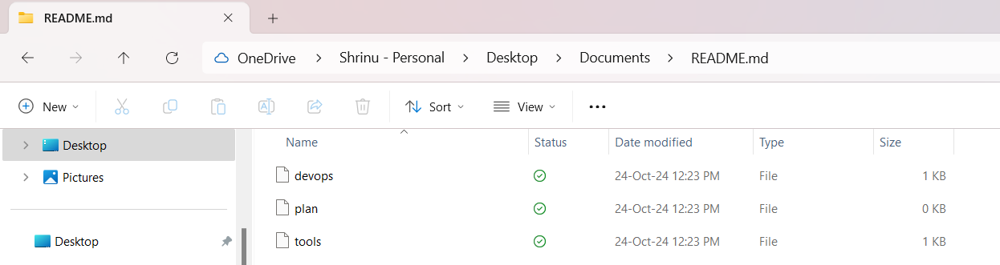**

**3)** Create two files in local repo.

we can use the touch command to create empty files or use echo to create files with initial content.

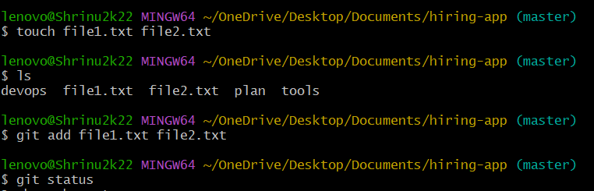

Now we have two new files in your local repository, and they are committed to your Git history

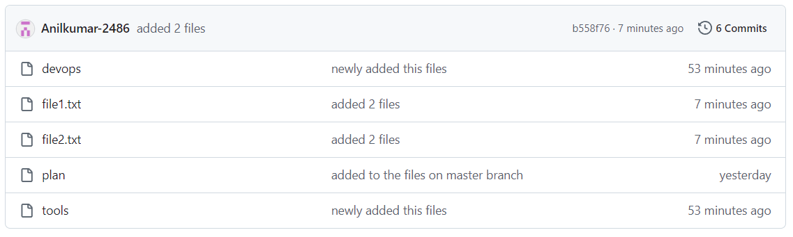

**4)** Commit two files and push to central Repository

Commands:- touch file1.txt, file2.txt  
 git add . (or) file1.txt file2.txt  
 git commit –m  
 git push –u origin (Branch Name)

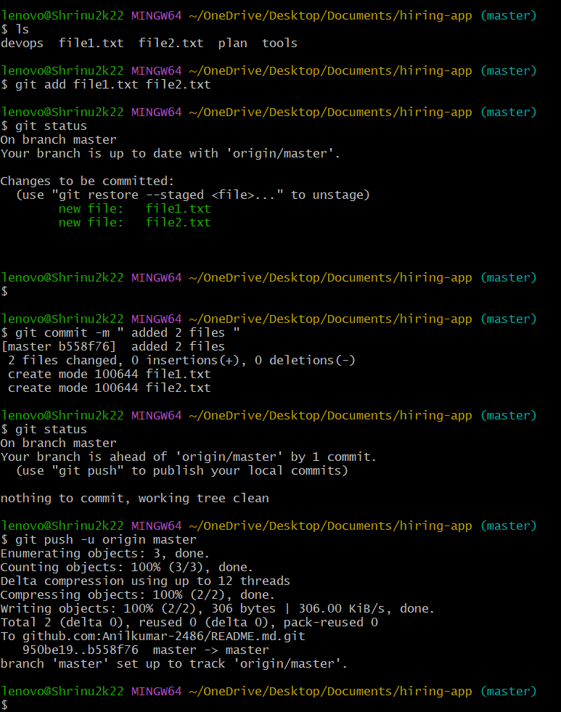

**5)** Create a branch in local and create a sample file and push to central.

To create a new branch in your local repository, add a sample file, and push it to the central GitHub repository

Created the anil branch

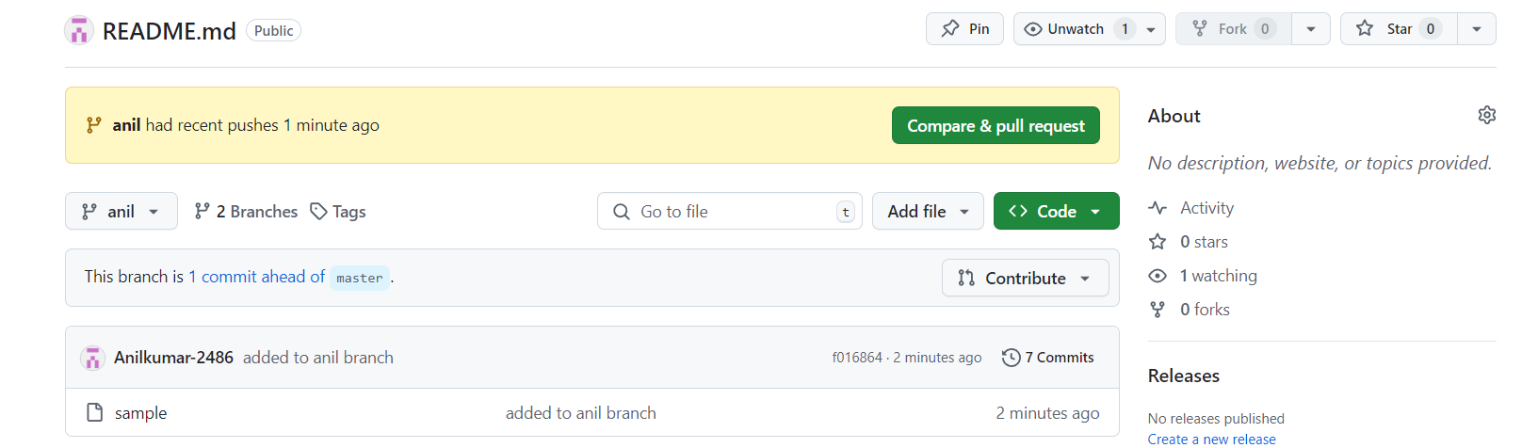

**Changed the branch**

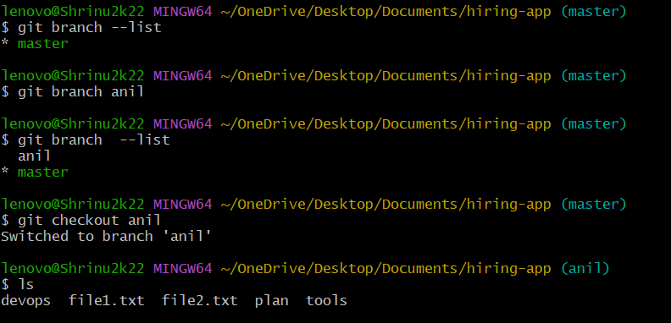

**Push the anil branch with 2 files**

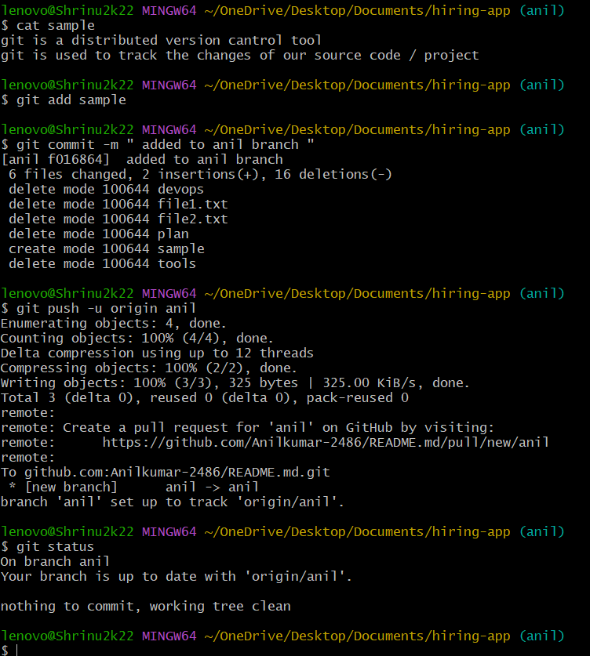

**6)** Create a branch in github and clone that to local.

--- > Go to your repository open your repository on github

--- > Create new branch

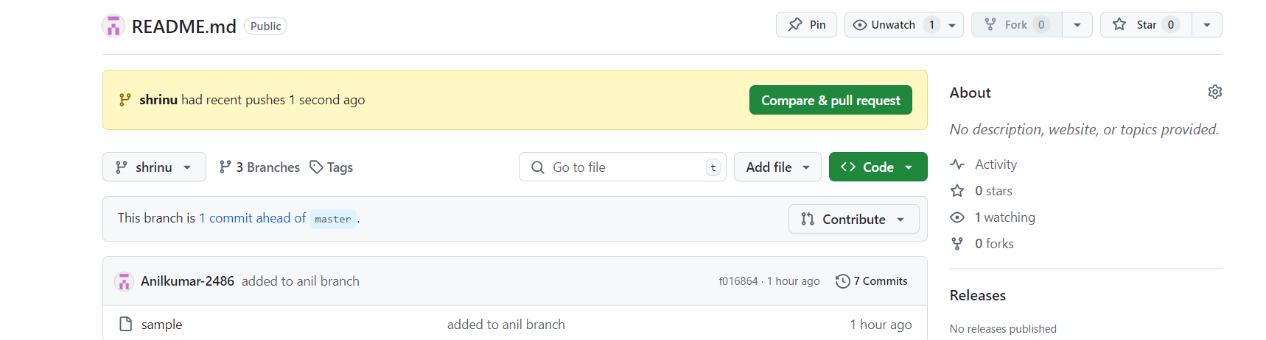

--- > open gitbash on your local machine

--- > use the git clone command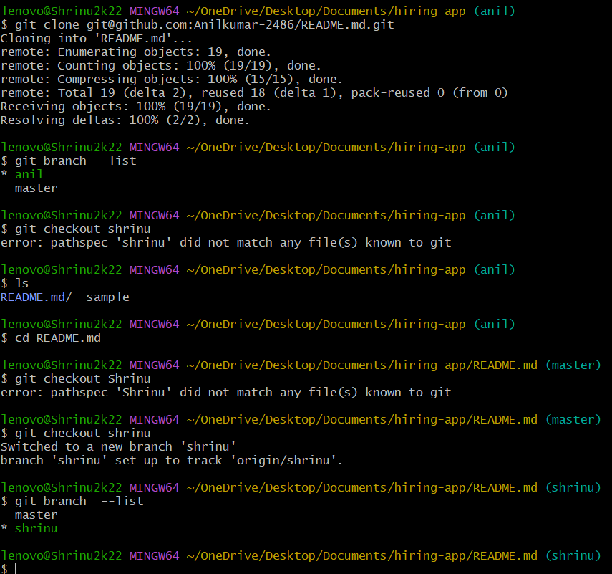

7) Check all the logs of git.

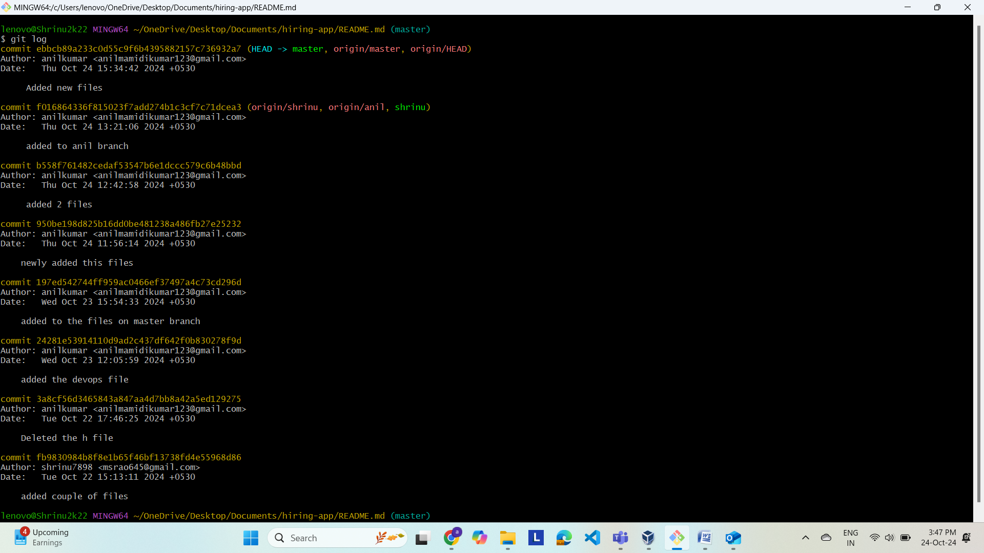

8) Rename the commit message.

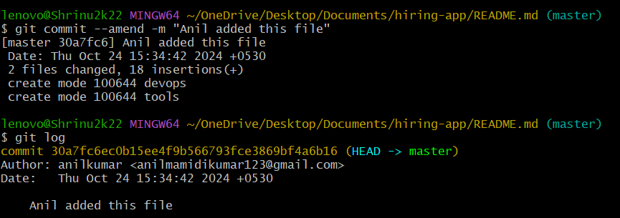

9) basic understanding of .git file.

The .git directory is a crucial part of any Git repository. It contains all the metadata and objects that Git needs to manage version control for your project. Here’s a basic overview of its contents

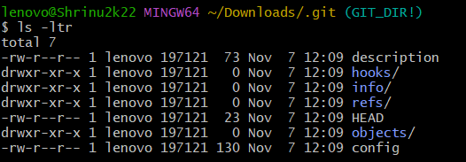

10) generate a ssh-keygen and configure into github.

a) open teriminal

b) generate the ssh key

command :- ssh-keygen

**Navigate to SSH and GPG keys**:

* Click on your profile picture in the top right corner.
* Go to **Settings**.
* In the left sidebar, click on **SSH and GPG keys**.

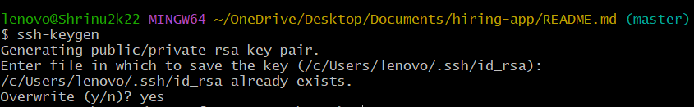

11) Merge the created branch with master in git local.

To merge a created branch with the master branch in your local Git repository

Commands :- git checkout – branch name

git merge branch name

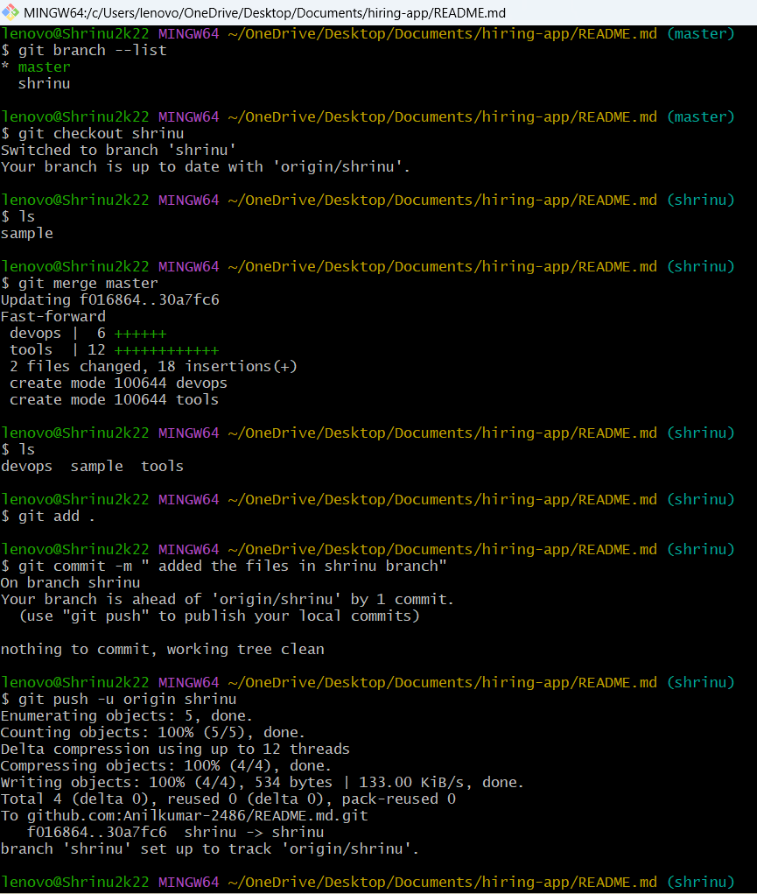

12) Merge the created branch with master in github by sending a pull request.

• Click on the "Pull requests" tab.

• Click the "New pull request" button.

• Select your branch (the one you want to merge) from the "compare" dropdown. Ensure master.

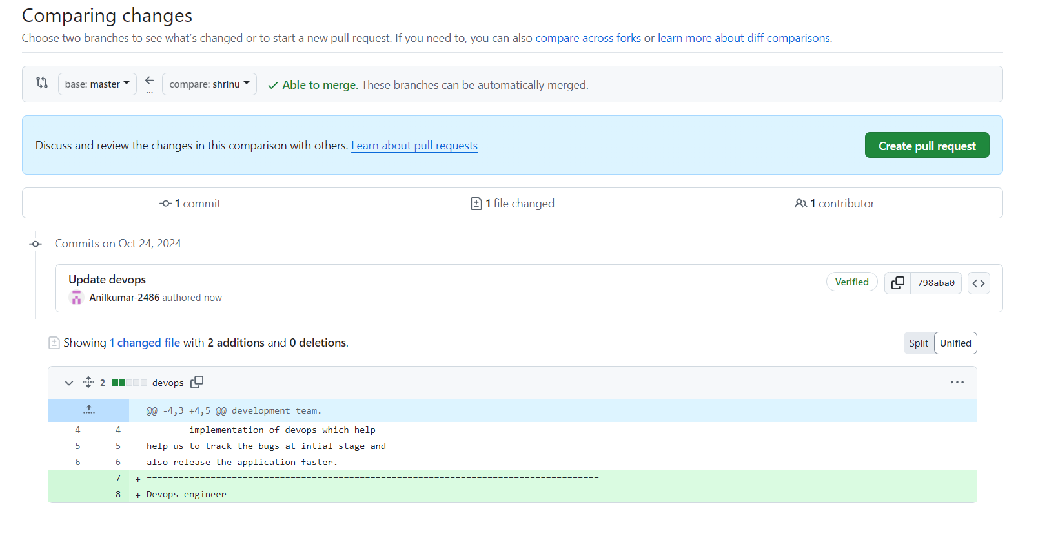

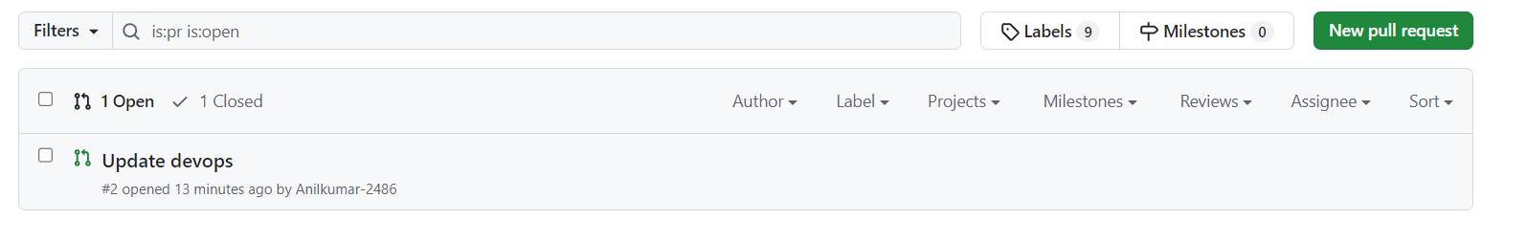

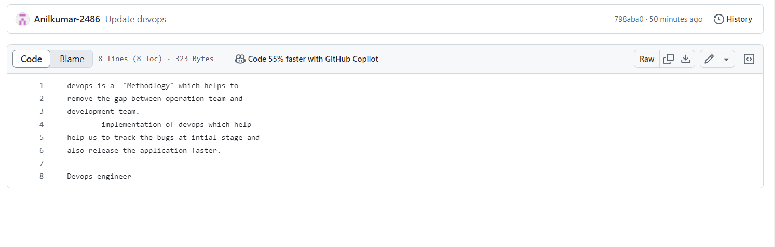

13) clone only a branch from github to local.

To clone only a specific branch from a GitHub repository to your local machine, you can use the following steps:

1. **Open your terminal (or command prompt)**.
2. **Use the git clone command with the shrinu** with the name of the branch you want to clone, and repository-url with the URL of the GitHub repository.

Command git clone --single-branch --branch branch-name repository-url

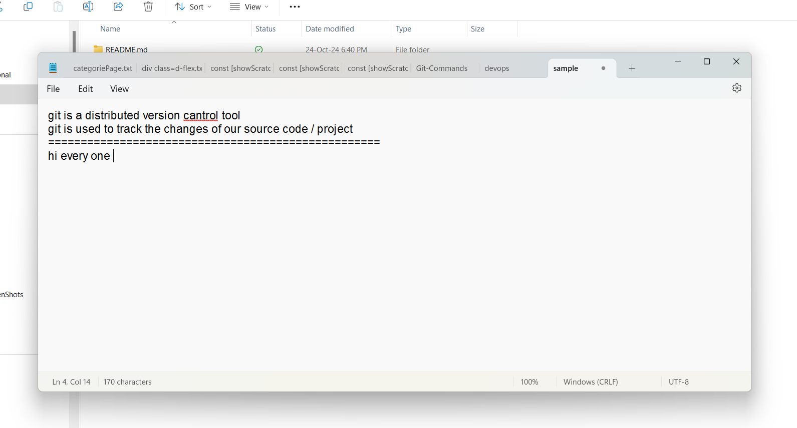





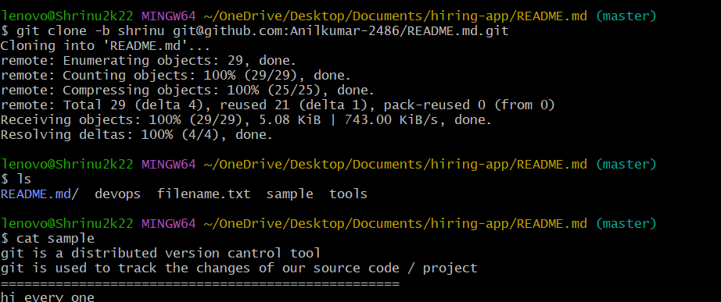

14) push a file to stash without savings the changes and work on another file.

If you want to push a file to the stash without saving the changes (effectively ignoring that file while keeping your current work), you can use the git stash command with a bit of extra handling.

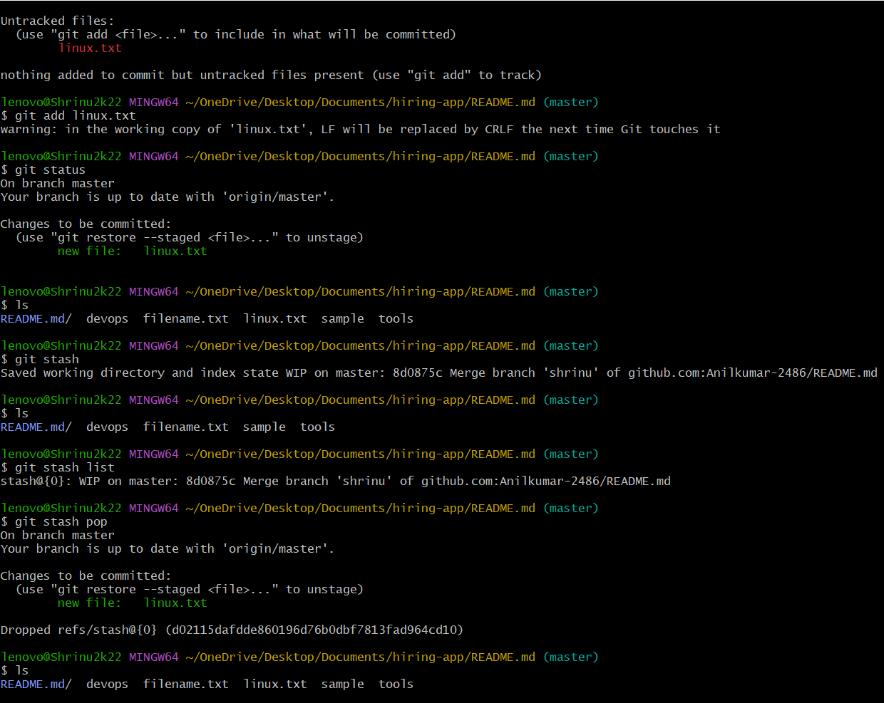

15)Revert a commited commit to the older version.

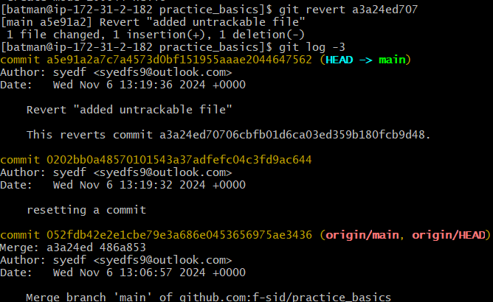

15) push a file to stash without savings the changes and work on another file.

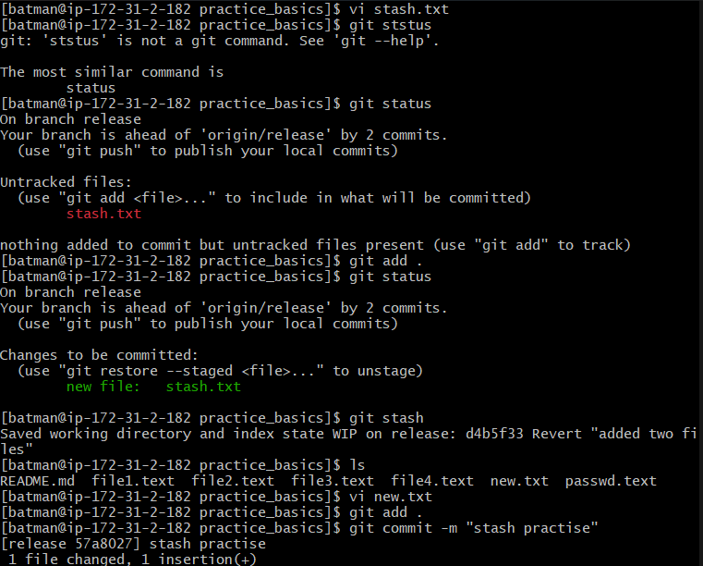

16) generate a ssh-keygen and configure into github.

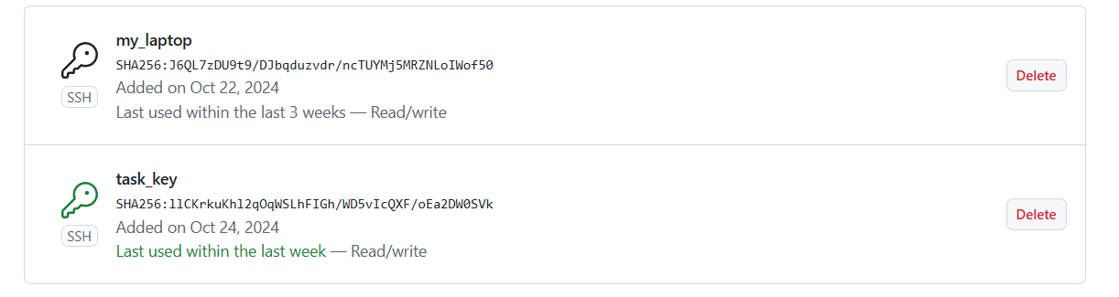

17) Merge multiple commits into single commit.

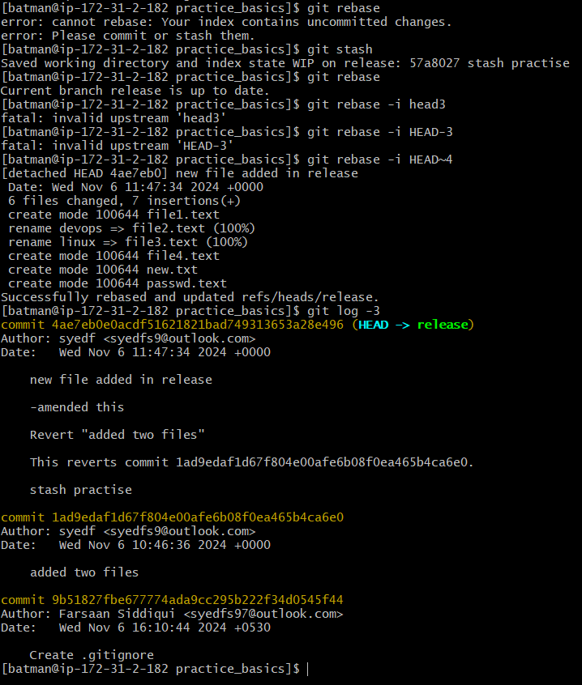

18 ) undo the stash file and start working on that again.

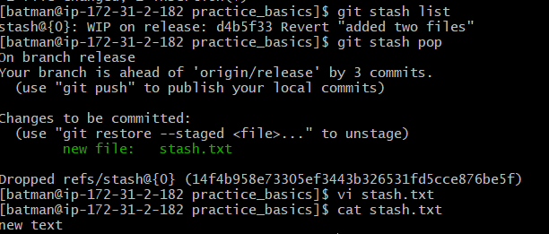

19)Revert a commited commit to the older version.

